March 2013
SMS Track and Field Calendar
Sunday | Monday | Tuesday | Wednesday | Thursday | Friday | Saturday
 |  |  |  |  | 1 | 2
3 | 4 | 5 | 6 | 7 | 8 | 9
 | Parent/Athlete Meeting  6:00 PM (Commons) | Practice 3:30-4:30 PM | Practice 3:30-4:30PM  (Field Events Only) | Practice 3:30-4:30PM
10 | 11 | 12 | 13 | 14 | 15 | 16
 | Practice 3:30-4:30 PM  (Field Events Only) | Practice 3:30-5:00 PM  (Body n Sole Shoe Fittings. Practice may run a little longer.) | Practice 3:30-4:30 PM  (Field Events Only) | Practice 3:30-4:30 PM
17 | 18 | 19 | 20 | 21 | 22 | 23
 | Practice 3:30-5:15 PM | Practice 3:30-5:15 PM | Practice 3:30-5:15 PM  (Pictures: Bring Uniforms) | Practice 3:30-5:15 PM | Practice 6:30-7:30 AM
24 | 25 | 26 | 27 | 28 | 29 | 30
 | Practice 3:30-5:15 PM | Practice 3:30-5:15 PM | Practice 3:30-5:15 PM | Practice 6:30-7:30 AM
31
 |  | 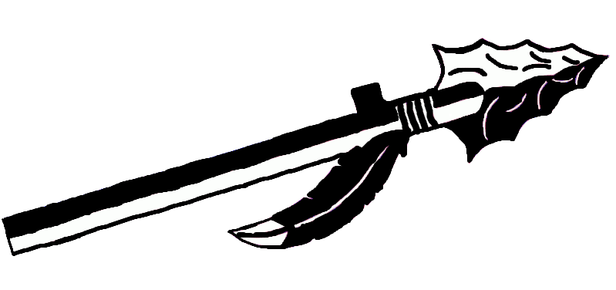
April 2013
SMS Track and Field Calendar
Sunday | Monday | Tuesday | Wednesday | Thursday | Friday | Saturday
 | 1 | 2 | 3 | 4 | 5 | 6
 | Practice 8:00-9:45 AM | Practice 8:00-9:45 AM |  | Practice 8:00-9:45 AM | Track Meet @ Mt. Zion  Dual Meet 4:00PM
7 | 8 | 9 | 10 | 11 | 12 | 13
 | Track Meet @ Mt. Zion JHS  Quad Meet 4:00PM | Practice 3:30-5:15 PM | Practice 3:30-5:15 PM | Practice 3:30-5:15 PM | Practice 6:30-7:30 AM | Track Meet @ Arthur  Invitational Meet 10:00AM
14 | 15 | 16 | 17 | 18 | 19 | 20
 | Practice 3:30-5:15 PM | Practice 3:30-5:15 PM | Practice 3:30-5:15 PM | Track Meet @ Shelbyville  Quad Meet 4:00 PM | Practice 7:00-7:30 | Track Meet @ Monticello  Invitational Meet 1:00 PM
21 | 22 | 23 | 24 | 25 | 26 | 27
 | Track Meet @ Home  Quad Meet 4:00PM | Practice 3:30-5:15 PM | Track Meet @ Clinton JHS  6th Grade Meet 4:15PM | Track Meet @ Home  Quad Meet 4:00PM | Practice 6:30-7:30 AM
28 | 29 | 30
 | Track Meet @ Home  Girls Conference Meet 3:45PM | Track Meet @ Shelbyville  Boys Conference Meet 3:45PM
May 2013
SMS Track and Field Calendar
Sunday | Monday | Tuesday | Wednesday | Thursday | Friday | Saturday
 |  |  | 1 | 2 | 3 | 4
 |  |  | Practice 3:30-5:15 PM | Track Meet @ Monticello  Dual Meet 4:30PM | Practice 6:30-7:30 AM
5 | 6 | 7 | 8 | 9 | 10 | 11
 | Track Meet @ Home  Quad Meet 4:00PM | Practice 3:30-5:15 PM | Practice 3:30-5:15 PM | Practice 3:30-5:15 PM | Practice 6:30-7:30 AM | Sectional Track Meet  TBA
12 | 13 | 14 | 15 | 16 | 17 | 18
 | Practice 3:30-5:15 PM  (State Qualifiers Only) | Practice 3:30-5:15 PM  (State Qualifiers Only) | Practice 3:30-5:15 PM  (State Qualifiers Only) | TBA | IESA State Track Meet  TBA | IESA State Track Meet  TBA
19 | 20 | 21 | 22 | 23 | 24 | 25
26 | 27 | 28 | 29 | 30 | 31

